***PATNA WOMENS COLLEGE***

***SESSION-2021-24***

# ASSIGNMENT OF NETWORKING

# SUBMITTED TO:

# SUBMITTED BY:

AMRITA MAM

NAME: ANAMIKA BASU

DEPARTMENT: BCA

SEMESTER: 3RD

ROLL NO: 92

EXAM ROLL NO: 21BCA01883

REGISTRATION NO: 21PWC01883

FORM ID: F-2021-9339

# 

# 

# OSI MODEL

*OPEN SYSTEM INTERCONNECTION (OSI) REFERENCE MODEL*

***The OSI Model (Open Systems Interconnection Model) is a conceptual framework used to describe the functions of a networking system.***

***OSI was introduced in 1983 by representatives of the major computer and telecom companies, and was adopted by ISO as an international standard in 1984.***

***It was the first standard model for network communications, adopted by all major computer and telecommunication companies in the early 1980s.***

1. ***Each layer has a separate level of abstraction.***
2. ***Each layer performs a defined function.***
3. ***Layers are defined to create international standardized protocol.***
4. ***Layers facilitates communication across infrastructure and applications.***
5. ***Each layer corresponds to a specific function within network communication.***

***THERE ARE SEVEN LAYERS IN OSI MODEL:***

* ***Physical layer***
* ***Data link layer***
* ***Network layer***
* ***Transport layer***
* ***Session layer***
* ***Presentation layer***
* ***Application layer***

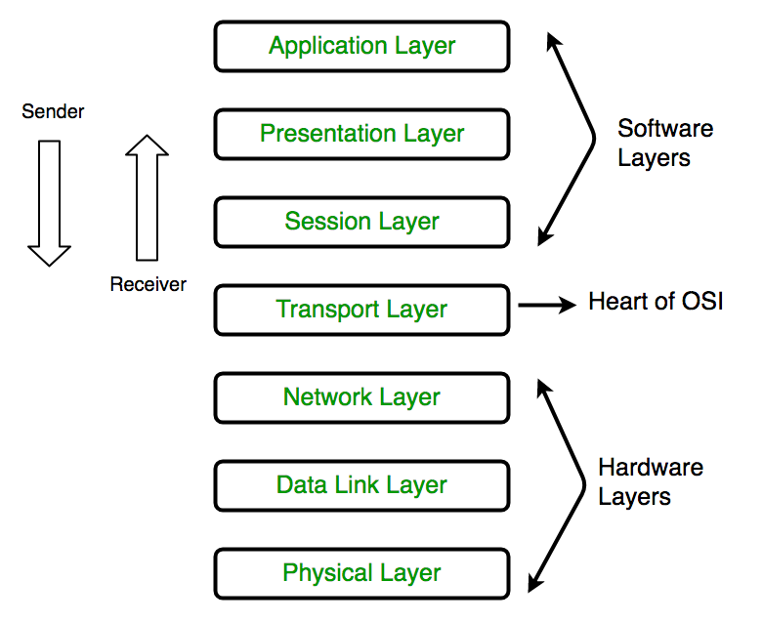

***Physical layer:*** The physical layer is responsible for the physical cable or wireless connection between network nodes. It defines the connector, the electrical cable or wireless technology connecting the devices, and is responsible for transmission of the raw data, which is simply a series of 0s and 1s, while taking care of bit rate control.

***Functions of physical layer:***

* **Line Configuration:** It defines the way how two or more devices can be connected physically.
* **Data Transmission:** It defines the transmission mode whether it is simplex, half-duplex or full-duplex mode between the two devices on the network.
* **Topology:** It defines the way how network devices are arranged.
* **Signals:** It determines the type of the signal used for transmitting the information.

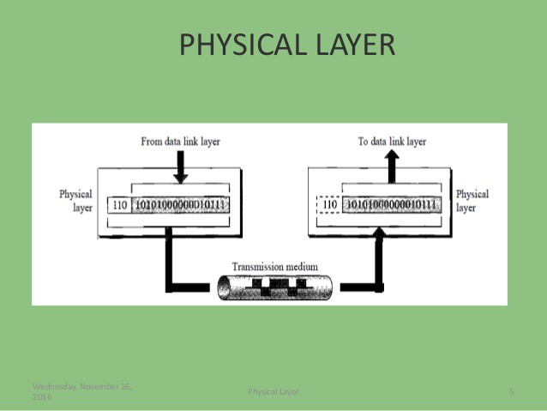

***Data link layer:*** The data link layer establishes and terminates a connection between two physically-connected nodes on a network. It breaks up packets into frames and sends them from source to destination. This layer is composed of two parts—Logical Link Control (LLC), which identifies network protocols, performs error checking and synchronizes frames, and Media Access Control (MAC) which uses MAC addresses to connect devices and define permissions to transmit and receive data.

***Functions of Data link layer:***

* **Framing:** The data link layer translates the physical's raw bit stream into packets known as Frames. The Data link layer adds the header and trailer to the frame. The header which is added to the frame contains the hardware destination and source address.
* **Physical Addressing:** The Data link layer adds a header to the frame that contains a destination address. The frame is transmitted to the destination address mentioned in the header.
* **Flow Control:** Flow control is the main functionality of the Data-link layer. It is the technique through which the constant data rate is maintained on both the sides so that no data get corrupted. It ensures that the transmitting station such as a server with higher processing speed does not exceed the receiving station, with lower processing speed.
* **Error Control:** Error control is achieved by adding a calculated value CRC (Cyclic Redundancy Check) that is placed to the Data link layer's trailer which is added to the message frame before it is sent to the physical layer. If any error seems to occurr, then the receiver sends the acknowledgment for the retransmission of the corrupted frames.
* **Access Control:** When two or more devices are connected to the same communication channel, then the data link layer protocols are used to determine which device has control over the link at a given time.

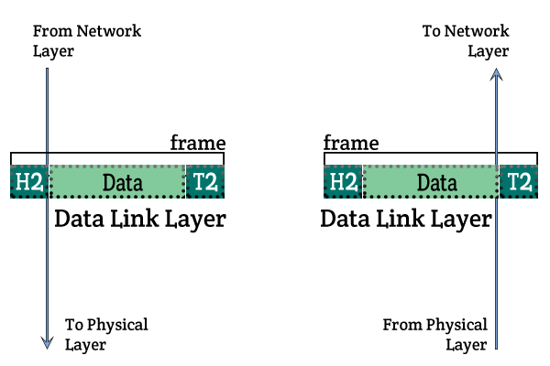

***Network layer:*** The network layer has two main functions. One is breaking up segments into network packets, and reassembling the packets on the receiving end. The other is routing packets by discovering the best path across a physical network. The network layer uses network addresses (typically Internet Protocol addresses) to route packets to a destination node.

***Functions of Network layer:***

* **Internetworking:** An internetworking is the main responsibility of the network layer. It provides a logical connection between different devices.
* **Addressing:** A Network layer adds the source and destination address to the header of the frame. Addressing is used to identify the device on the internet.
* **Routing:** Routing is the major component of the network layer, and it determines the best optimal path out of the multiple paths from source to the destination.

. **Packetizing:** A Network Layer receives the packets from the upper layer and converts them into packets. This process is known as Packetizing. It is achieved by internet protocol (IP).

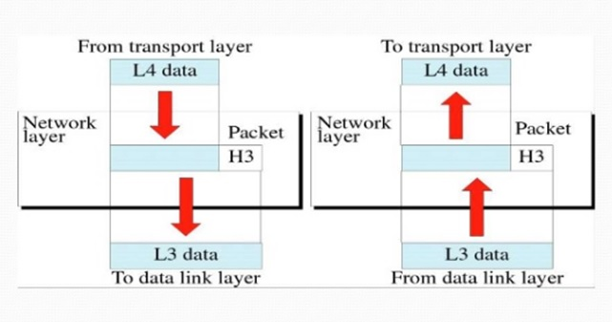

***Transport layer:*** The transport layer takes data transferred in the session layer and breaks it into “segments” on the transmitting end. It is responsible for reassembling the segments on the receiving end, turning it back into data that can be used by the session layer. The transport layer carries out flow control, sending data at a rate that matches the connection speed of the receiving device, and error control, checking if data was received incorrectly and if not, requesting it again.

***Function of Transport layer:***

* **Connection control:** Transport layer provides two services Connection-oriented service and connectionless service. A connectionless service treats each segment as an individual packet, and they all travel in different routes to reach the destination. A connection-oriented service makes a connection with the transport layer at the destination machine before delivering the packets. In connection-oriented service, all the packets travel in the single route.
* **Flow control:** The transport layer also responsible for flow control but it is performed endto-end rather than across a single link.
* **Error control:** The transport layer is also responsible for Error control. Error control is performed end-to-end rather than across the single link. The sender transport layer ensures that message reach at the destination without any error.

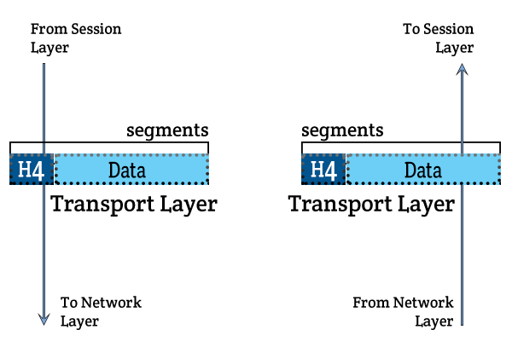

***Session layer:*** The session layer creates communication channels, called sessions, between devices. It is responsible for opening sessions, ensuring they remain open and functional while data is being transferred, and closing them when communication ends. The session layer can also set checkpoints during a data transfer—if the session is interrupted, devices can resume data transfer from the last checkpoint.

***Functions of Session layer:***

. **Dialog control:** Session layer acts as a dialog controller that creates a dialog between two processes or we can say that it allows the communication between two processes which can be either half-duplex or full-duplex.

* **Synchronization:** Session layer adds some checkpoints when transmitting the data in a sequence. If some error occurs in the middle of the transmission of data, then the transmission will take place again from the checkpoint. This process is known as Synchronization and recovery.

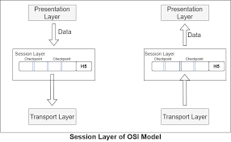

***Presentation layer:*** The presentation layer prepares data for the application layer.

It defines how two devices should encode, encrypt, and compress data so it is received correctly on the other end. The presentation layer takes any data transmitted by the application layer and prepares it for transmission over the session layer.

***Functions of Presentation layer:***

* **Translation:** The processes in two systems exchange the information in the form of character strings, numbers and so on. Different computers use different encoding methods, the presentation layer handles the interoperability between the different encoding methods. It converts the data from sender-dependent format into a common format and changes the common format into receiver-dependent format at the receiving end.
* **Encryption:** Encryption is needed to maintain privacy. Encryption is a process of converting the sender-transmitted information into another form and sends the resulting message over the network.
* **Compression:** Data compression is a process of compressing the data, i.e., it reduces the number of bits to be transmitted. Data compression is very important in multimedia such as text, audio, video.

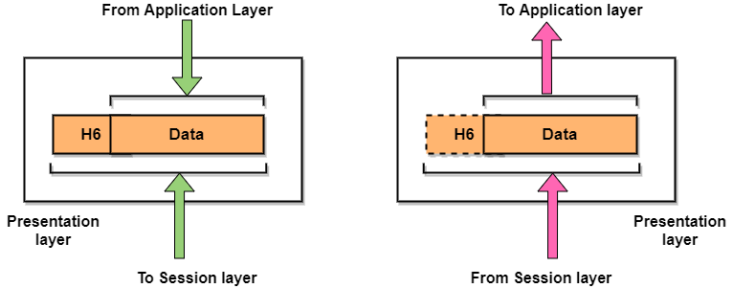

***Application layer:*** The application layer is used by end-user software such as web browsers and email clients. It provides protocols that allow software to send and receive information and present meaningful data to users. A few examples of application layer protocols are the Hypertext transfer protocol (HTTP), File Transfer

Protocol (FTP), Post Office Protocol (POP), Simple Mail Transfer Protocol (SMTP), and Domain Name System (DNS).

***Function of Application layer:***

* **File transfer, access, and management (FTAM):** An application layer allows a user to access the files in a remote computer, to retrieve the files from a computer and to manage the files in a remote computer.
* **Mail services:** An application layer provides the facility for email forwarding and storage.
* **Directory services**: An application provides the distributed database sources and is used to provide that global information about various objects  ***.***

